Animal Guessing Game
Directions: Use the underlined verbs to help you move like different animals. Ask a family member to guess the animals.
Fly like a bird. 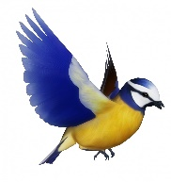
Stomp like an elephant. 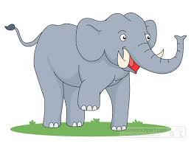
Scurry like a chipmunk. 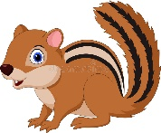
Flutter like a butterfly. 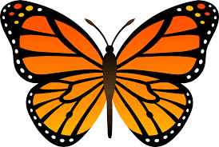
Slither like a snake. 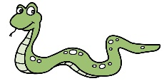
Swim like a fish. 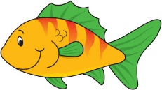
Hop like a frog. 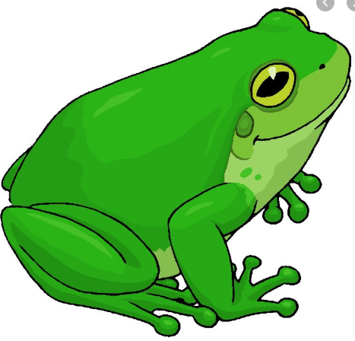
Reach like a giraffe. 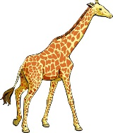
Gallop like a horse. 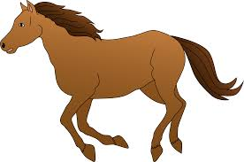
Waddle like a penguin. 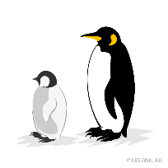
Prowl like a lion. 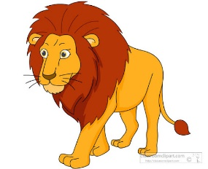
Jump like a kangaroo. 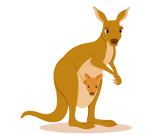

Challenge: Now try making up some of your own!

